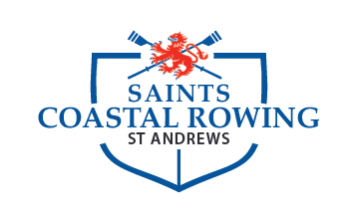
Saints Regatta, 8-9th September 2023
East Sands, St Andrews, Fife

The University of St Andrews Boat Club, with the University of St Andrews and Scottish Rowing, is pleased to announce Saints Regatta.

This will be the second Coastal edition of Saints Regatta, and we aim to build on the success of last year’s event. With training and student events on the Friday, and Junior and Open events on the Saturday, the event will cater to all levels of beach sprint experience and competition.

Events offered:
Women’s Coastal 1x, Men’s Coastal 1x, Mixed Coastal 2x and mixed Coastal 4x+
There will also be age category events for juniors.

Entry fees:
M/W C1x: £35
Mix C2x: £60
Mix C4x+: £120

Entries open: FRIDAY 11th AUGUST, 9am
Entries close: FRIDAY 1st SEPTEMER, 7pm

Payment: Entry fees to be paid be via invoice to UStABC. Entries will be conducted via email.

Enquiries: saintsregatta@st-andrews.ac.uk.

By entering our event you are confirming that the crews are competent rowers who will be able to manage coastal rowing, or that they have coastal experience.

Held in accordance with the Rules of Scottish Rowing. Late entries will not be accepted. If no payment is received before the draw on Tuesday 5th September 2023, those entries will be removed.

SHORT, SHARP, SPRINTS.

